20140616 Linux Kernel Crash Capture and Analysis.pdf

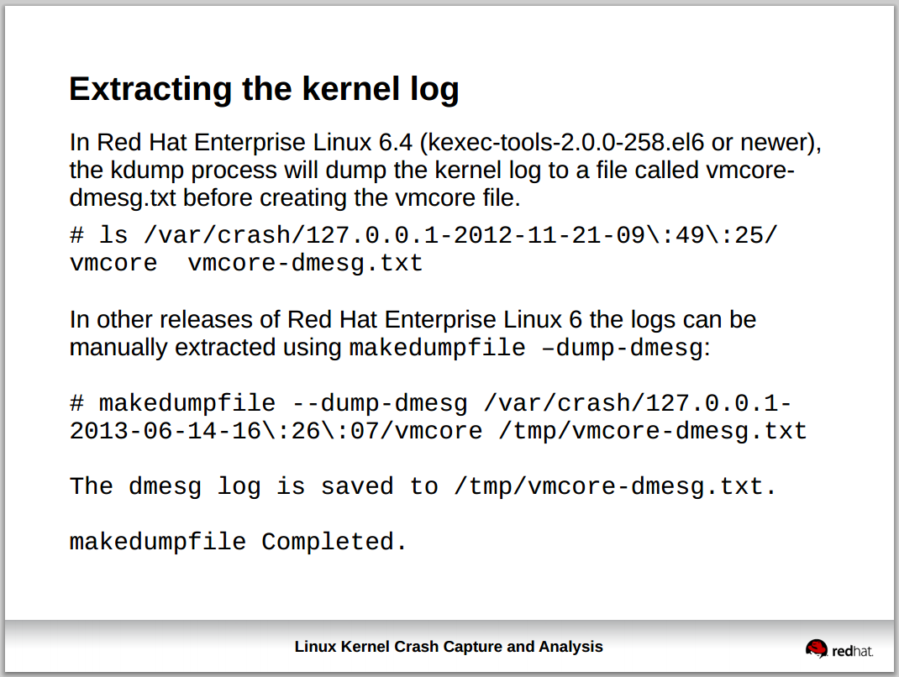

[root@smdw_prod ~]# makedumpfile --dump-dmesg /var/crash/127.0.0.1-2014-06-05-13\:29\:52/vmcore /var/crash/127.0.0.1-2014-06-05-13\:29\:52/vmcore-dmesg.txt

The dmesg log is saved to /var/crash/127.0.0.1-2014-06-05-13:29:52/vmcore-dmesg.txt.

makedumpfile Completed.
[root@smdw_prod ~]#

